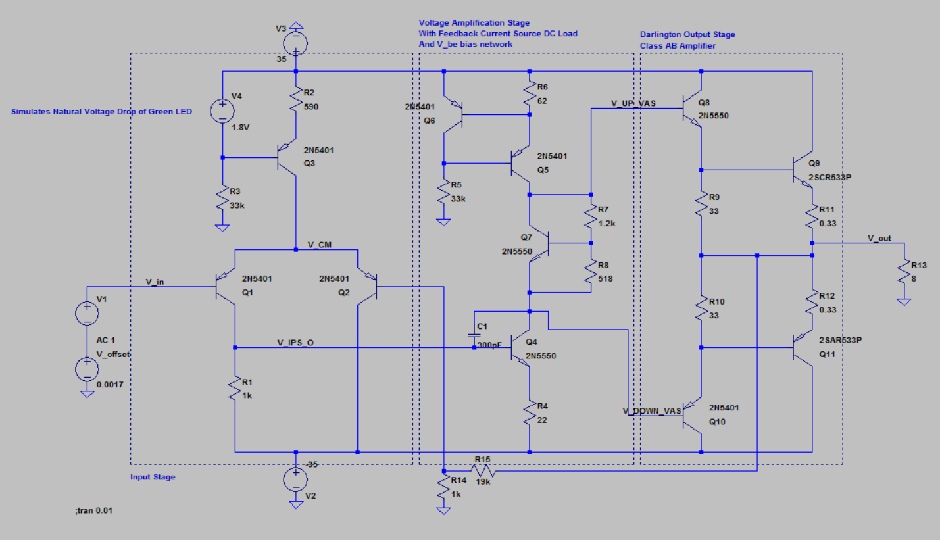

Config 1.0

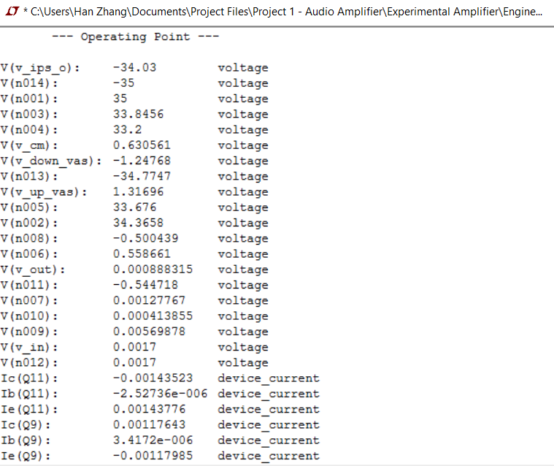

DC Operating Points of Config. 1.0.

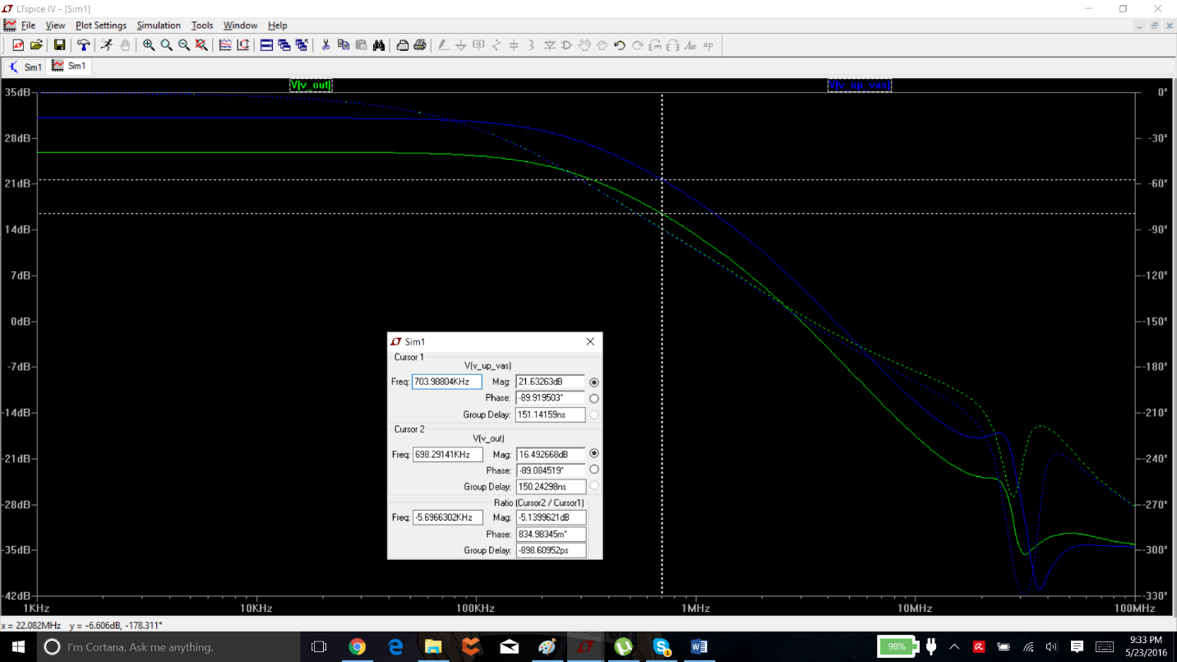

Roughly 6db loss from VAS to Output Stage

Plenty of Stability Margin

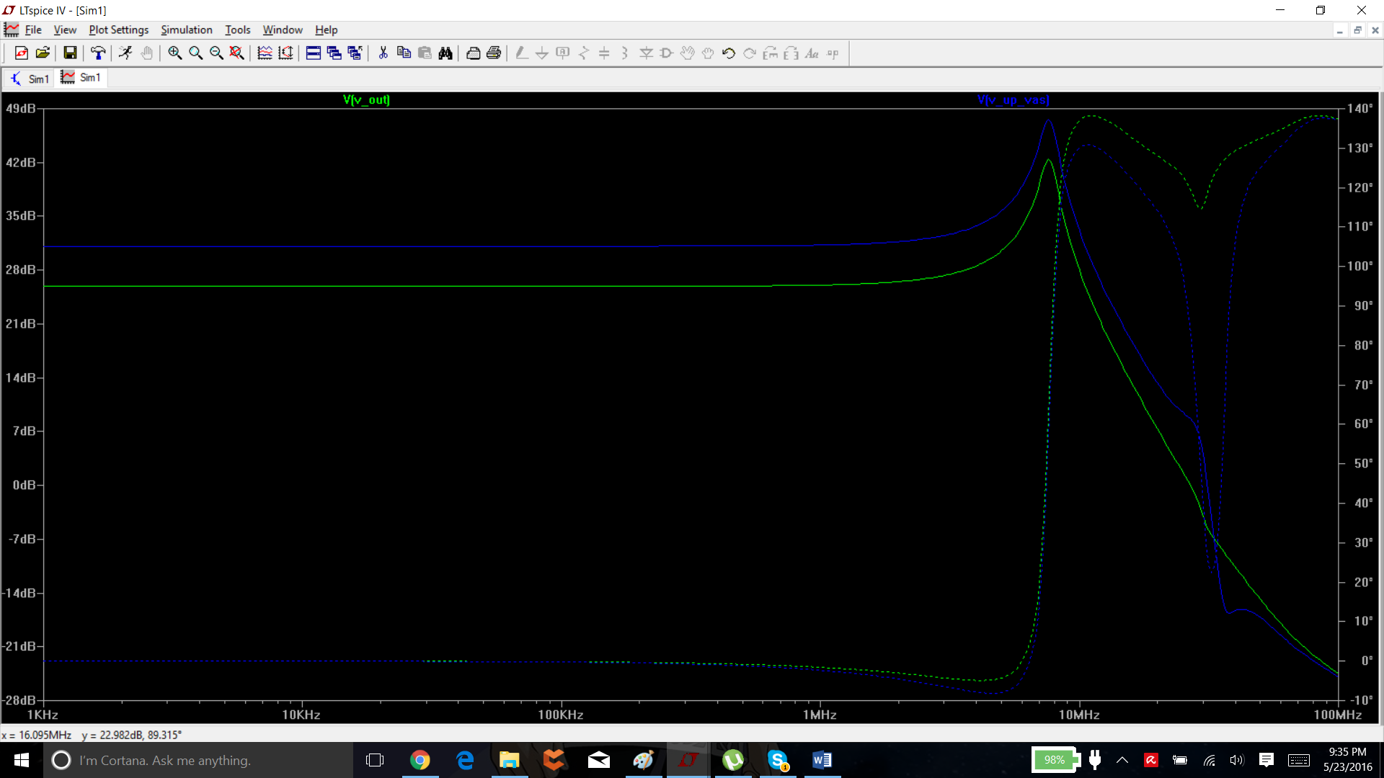

Without Miller Compensation on VAS

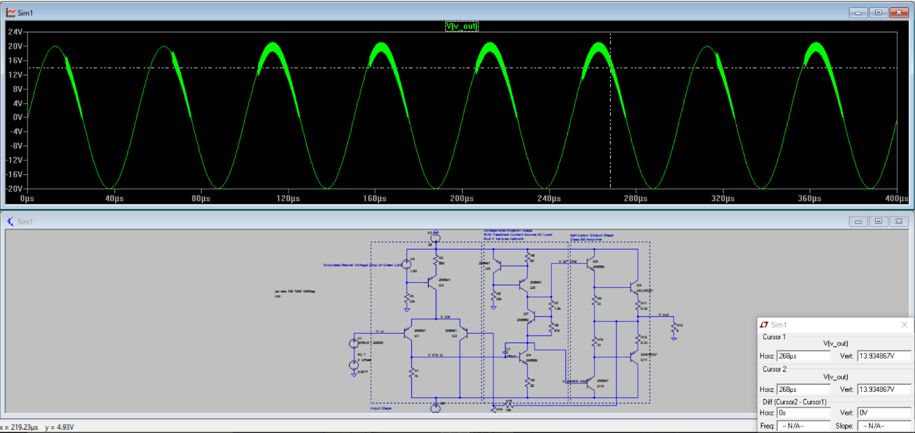

20kHz Transient Response.

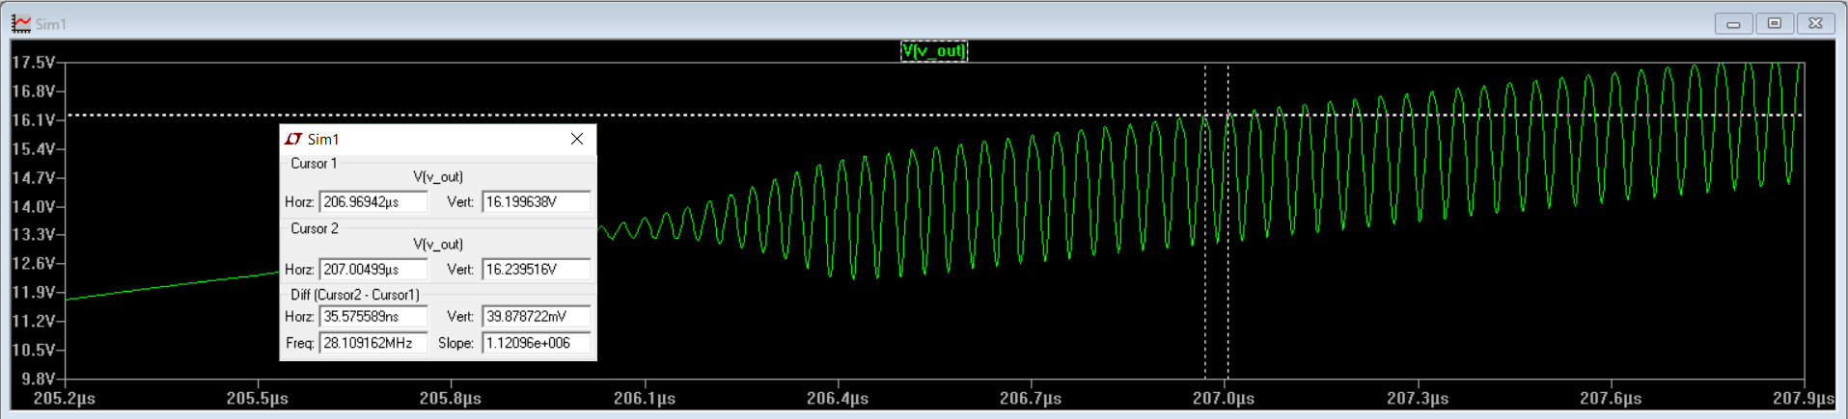

Instability at Fres of 2.8 MHz

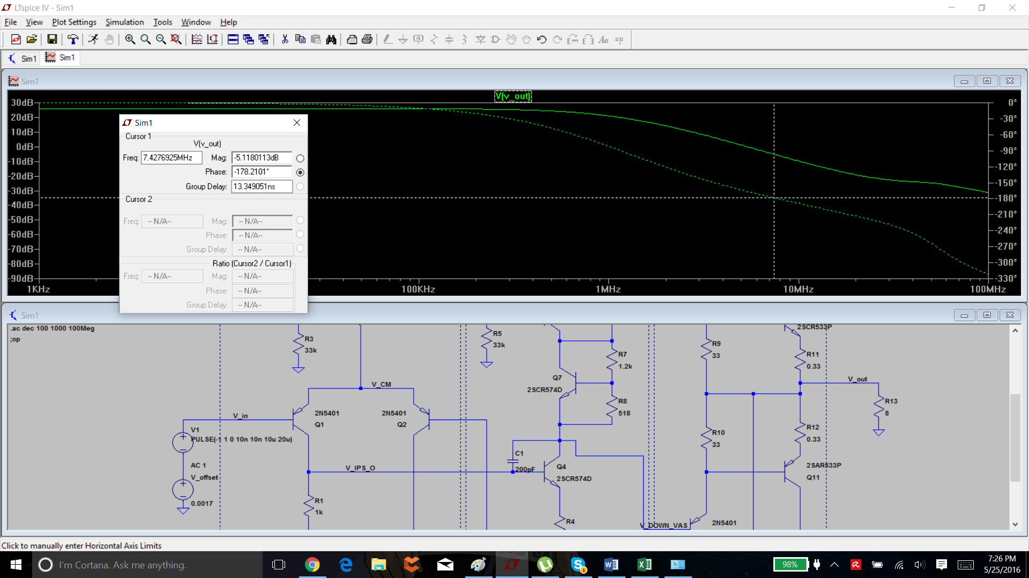

Switching from 2N5550 to 2SCR574D eliminated ringing.

NPN(Is=2.511f Xti=3 Eg=1.11 Vaf=100 Bf=213.4 Ne=1.241 Ise=2.511f Ikf=.3495 Xtb=1.5 Br=3.24 Nc=2 Isc=0 Ikr=0 Rc=1 Cjc=4.883p

+ Mjc=.3047 Vjc=.75 Fc=.5 Cje=18.79p Mje=.3416 Vje=.75 Tr=1.212n Tf=560.1p Itf=50m Vtf=5 Xtf=8 Rb=10 Vceo=150 Icrating=600m mfg=Fairchild)

Vs

.model 2SCR574D NPN(Is=1.0000E-12 Bf=226.21 Vaf=103.70 Ikf=15 Ise=1.0000E-12 Ne=1.5805 Br=78.835 Var=43 Ikr=1.3435 Isc=5.2175E-12 Nc=1.2893 Nk=1.0840 Re=30.000E-3 Rb=1.4908 Rc=55.610E-3 Cje=496.19E-12 Vje=.76899 Mje=.35078 Cjc=63.898E-12 Vjc=.75325 Mjc=.4557 Tf=498.62E-12 Xtf=454.99 Vtf=242.95 Itf=83.905 Tr=33.570E-9 Xtb=1.2500 TRE1=0.005 Vceo=80 Icrating=2 mfg=Rohm)

2n5550 has no simulated cjc.

Cjc is zero bias junction capacitance from base to collector.

Reducing Miller Compensation by 63 pf and checking response on VAS: no difference. Slightly less clipping. Likely response to higher frequencies.

Adding CJC manually to simulations with 2n5550 eliminated ringing issues.

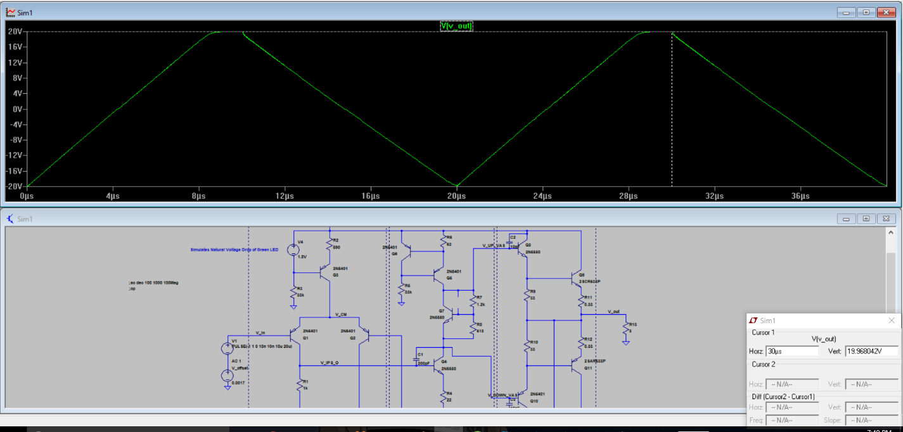

1kHz harmonic analysis

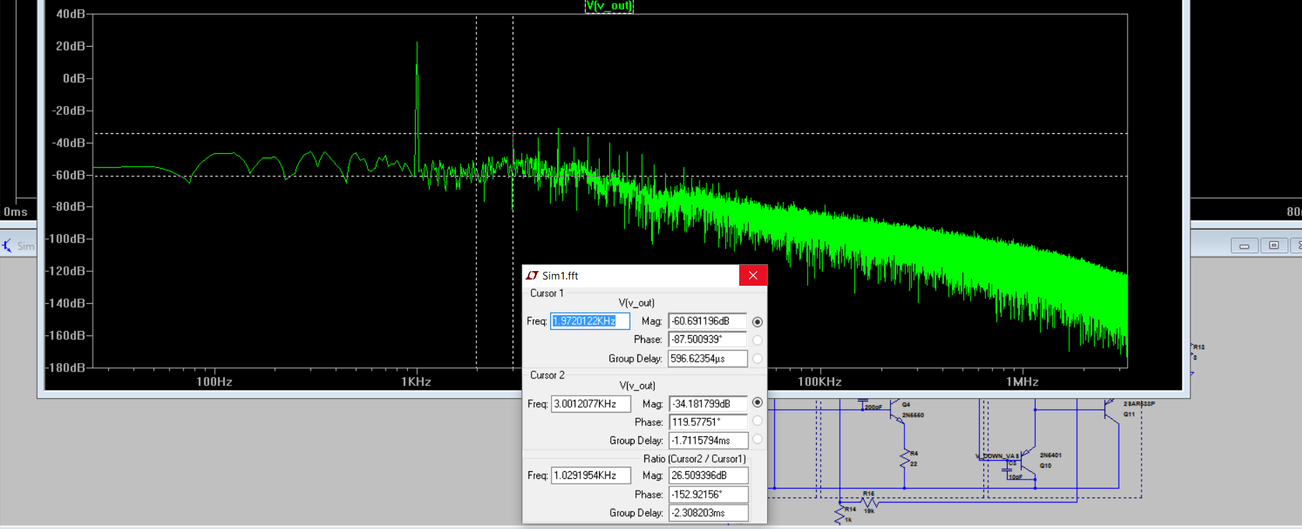

For some reason third harmonic was much higher.

20kHz harmonic analysis

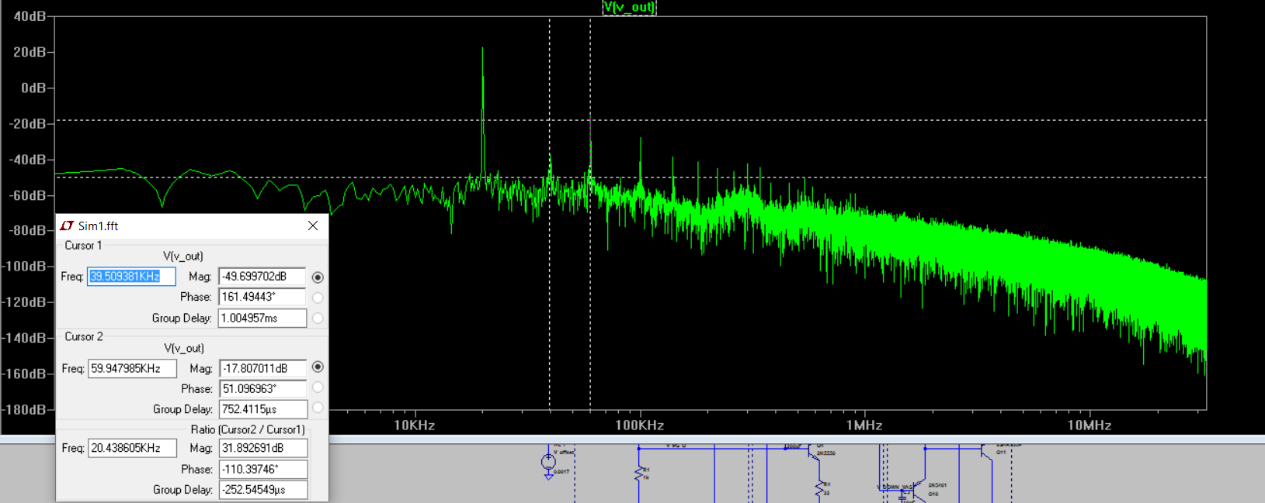

Direct Newton iteration for .op point succeeded.

N-Period=4

Fourier components of V(v_out)

DC component:0.0295624

Harmonic Frequency Fourier Normalized Phase Normalized

Number [Hz] Component Component [degree] Phase [deg]

1 2.000e+04 1.979e+01 1.000e+00 -1.95° 0.00°

2 4.000e+04 1.766e-02 8.923e-04 19.89° 21.83°

3 6.000e+04 8.426e-02 4.258e-03 -92.85° -90.90°

4 8.000e+04 1.394e-02 7.042e-04 -99.18° -97.23°

5 1.000e+05 3.416e-02 1.726e-03 -18.59° -16.64°

6 1.200e+05 2.284e-02 1.154e-03 67.27° 69.22°

7 1.400e+05 2.721e-02 1.375e-03 -174.18° -172.24°

8 1.600e+05 4.803e-03 2.427e-04 33.35° 35.30°

9 1.800e+05 6.621e-03 3.346e-04 35.69° 37.64°

10 2.000e+05 9.589e-03 4.846e-04 -155.04° -153.09°

Total Harmonic Distortion: 0.510189%(0.564838%)

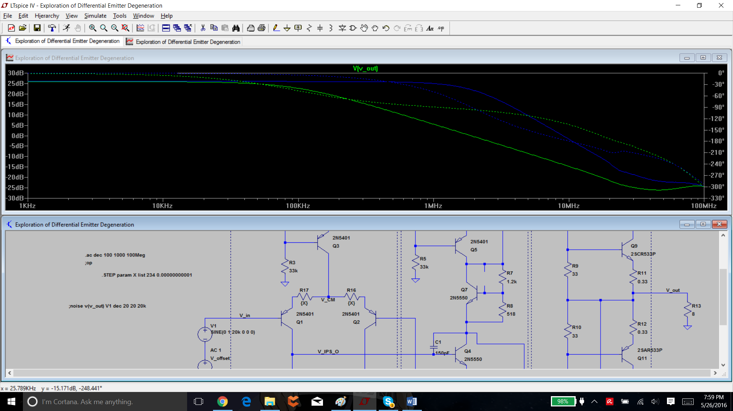

Miller capacitance not changed. Effective load on collector of IPS reduced greatly at high frequencies -> acts essentially as a low pass filter with 3dB point shifted to lower frequency. Want more bandwith

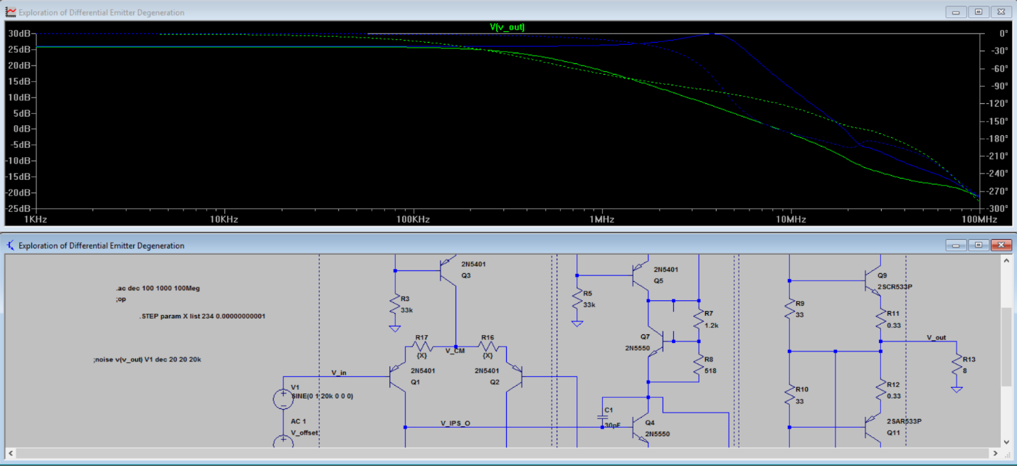

More bandwidth -> higher gain at higher freq -> more impedance at higher frequencies -> smaller capacitance value. Emitter degeneration prevents harmful peaking at 7MHz.

Why is there peaking? I have no clue.

Blue is no emitter degeneration. Green is with.

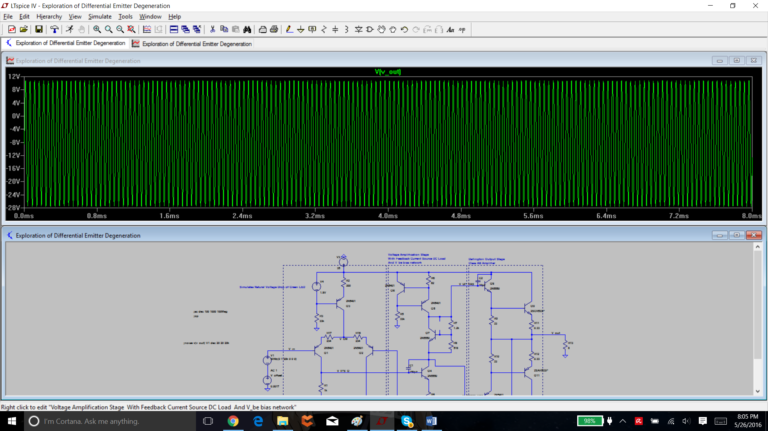

Dc setpoint changed as a result of emitter degen.

Shifted setpoint to recenter -> bias voltage = 0.43V. -> likely output will just have dc decoupling capacitor with high bandwidth.

Direct Newton iteration for .op point succeeded.

N-Period=4

Fourier components of V(v_out)

DC component:7.7122

Harmonic Frequency Fourier Normalized Phase Normalized

Number [Hz] Component Component [degree] Phase [deg]

1 2.000e+04 1.985e+01 1.000e+00 -0.97° 0.00°

2 4.000e+04 8.260e-03 4.161e-04 153.65° 154.62°

3 6.000e+04 6.838e-03 3.445e-04 -93.95° -92.99°

4 8.000e+04 2.066e-02 1.041e-03 41.30° 42.26°

5 1.000e+05 2.888e-02 1.455e-03 -17.56° -16.60°

6 1.200e+05 1.889e-02 9.516e-04 -64.72° -63.75°

7 1.400e+05 1.842e-02 9.277e-04 -110.58° -109.62°

8 1.600e+05 1.490e-02 7.508e-04 83.48° 84.45°

9 1.800e+05 2.555e-02 1.287e-03 66.18° 67.15°

10 2.000e+05 6.098e-03 3.072e-04 -168.45° -167.49°

Total Harmonic Distortion: 0.275166%(0.391936%)

Direct Newton iteration for .op point succeeded.

N-Period=4

Fourier components of V(v_out)

DC component:-0.0797367

Harmonic Frequency Fourier Normalized Phase Normalized

Number [Hz] Component Component [degree] Phase [deg]

1 2.000e+04 1.908e+01 1.000e+00 -11.80° 0.00°

2 4.000e+04 4.789e-02 2.511e-03 -132.40° -120.59°

3 6.000e+04 1.063e-01 5.573e-03 -121.80° -110.00°

4 8.000e+04 4.892e-03 2.564e-04 -155.26° -143.46°

5 1.000e+05 1.648e-02 8.637e-04 15.84° 27.64°

6 1.200e+05 1.638e-02 8.587e-04 -9.39° 2.41°

7 1.400e+05 3.416e-02 1.791e-03 149.57° 161.37°

8 1.600e+05 2.439e-03 1.279e-04 5.76° 17.57°

9 1.800e+05 1.644e-02 8.618e-04 42.70° 54.51°

10 2.000e+05 7.638e-03 4.004e-04 103.10° 114.90°

Total Harmonic Distortion: 0.656042%(0.711274%)

Turns out there’s more Harmonic Distortion with emitter degeneration. Tradeoff is more gain margin.

For 1kHz point.

Direct Newton iteration for .op point succeeded.

N-Period=4

Fourier components of V(v_out)

DC component:-0.0702465

Harmonic Frequency Fourier Normalized Phase Normalized

Number [Hz] Component Component [degree] Phase [deg]

1 1.000e+03 1.959e+01 1.000e+00 -0.60° 0.00°

2 2.000e+03 1.639e-02 8.365e-04 -90.91° -90.30°

3 3.000e+03 5.398e-03 2.755e-04 -164.13° -163.53°

4 4.000e+03 9.726e-04 4.964e-05 104.16° 104.77°

5 5.000e+03 2.946e-03 1.503e-04 -163.05° -162.45°

6 6.000e+03 1.008e-03 5.146e-05 -94.86° -94.25°

7 7.000e+03 3.430e-03 1.751e-04 -144.72° -144.12°

8 8.000e+03 1.027e-03 5.241e-05 107.07° 107.68°

9 9.000e+03 1.813e-03 9.252e-05 -49.90° -49.30°

10 1.000e+04 7.133e-04 3.641e-05 -79.50° -78.89°

Total Harmonic Distortion: 0.092011%(0.112066%)

And without the emitter degeneration.

Direct Newton iteration for .op point succeeded.

N-Period=4

Fourier components of V(v_out)

DC component:7.75952

Harmonic Frequency Fourier Normalized Phase Normalized

Number [Hz] Component Component [degree] Phase [deg]

1 1.000e+03 1.988e+01 1.000e+00 -0.04° 0.00°

2 2.000e+03 4.794e-03 2.411e-04 -115.32° -115.28°

3 3.000e+03 6.122e-03 3.079e-04 -15.55° -15.50°

4 4.000e+03 6.806e-04 3.423e-05 111.81° 111.86°

5 5.000e+03 6.850e-03 3.445e-04 -20.08° -20.04°

6 6.000e+03 4.730e-03 2.379e-04 65.46° 65.51°

7 7.000e+03 2.368e-03 1.191e-04 -111.08° -111.03°

8 8.000e+03 4.968e-03 2.499e-04 41.75° 41.79°

9 9.000e+03 2.653e-03 1.335e-04 124.70° 124.74°

10 1.000e+04 1.217e-03 6.123e-05 4.32° 4.36°

Total Harmonic Distortion: 0.065391%(0.090170%)

Similar case.

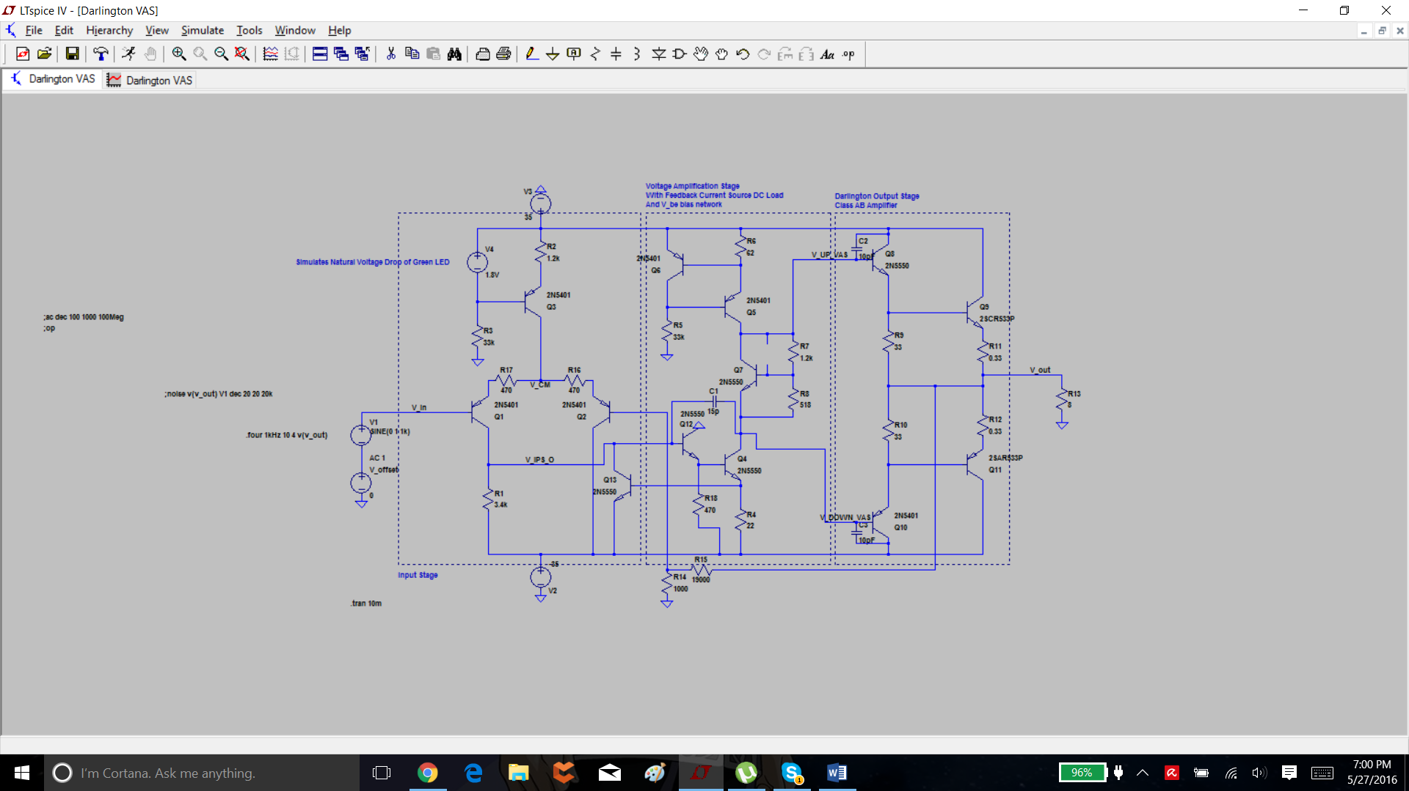

With Darlington VAS.

Fourier components of V(v_out)

DC component:0.489182

Harmonic Frequency Fourier Normalized Phase Normalized

Number [Hz] Component Component [degree] Phase [deg]

1 1.000e+03 1.985e+01 1.000e+00 -0.12° 0.00°

2 2.000e+03 2.145e-03 1.080e-04 -90.74° -90.62°

3 3.000e+03 2.310e-03 1.164e-04 -171.65° -171.52°

4 4.000e+03 4.359e-04 2.196e-05 93.15° 93.27°

5 5.000e+03 1.091e-03 5.494e-05 -169.43° -169.31°

6 6.000e+03 2.831e-03 1.426e-04 -86.01° -85.88°

7 7.000e+03 3.263e-03 1.644e-04 -171.77° -171.64°

8 8.000e+03 8.698e-04 4.381e-05 91.35° 91.48°

9 9.000e+03 7.147e-04 3.600e-05 -151.80° -151.68°

10 1.000e+04 6.764e-04 3.407e-05 92.93° 93.06°

Total Harmonic Distortion: 0.028362%(0.035177%)

THD-1 Has gone down substantially.

Fourier components of V(v_out)

DC component:0.494966

Harmonic Frequency Fourier Normalized Phase Normalized

Number [Hz] Component Component [degree] Phase [deg]

1 2.000e+04 1.979e+01 1.000e+00 -2.44° 0.00°

2 4.000e+04 1.263e-02 6.383e-04 -53.12° -50.68°

3 6.000e+04 2.490e-02 1.258e-03 -60.31° -57.87°

4 8.000e+04 4.637e-03 2.343e-04 177.99° 180.43°

5 1.000e+05 7.647e-03 3.864e-04 -102.63° -100.19°

6 1.200e+05 5.543e-03 2.801e-04 46.85° 49.29°

7 1.400e+05 9.238e-03 4.668e-04 -174.48° -172.04°

8 1.600e+05 3.011e-03 1.522e-04 -74.19° -71.75°

9 1.800e+05 4.827e-03 2.439e-04 -170.12° -167.67°

10 2.000e+05 2.631e-03 1.329e-04 -116.13° -113.69°

Total Harmonic Distortion: 0.160973%(0.200208%)

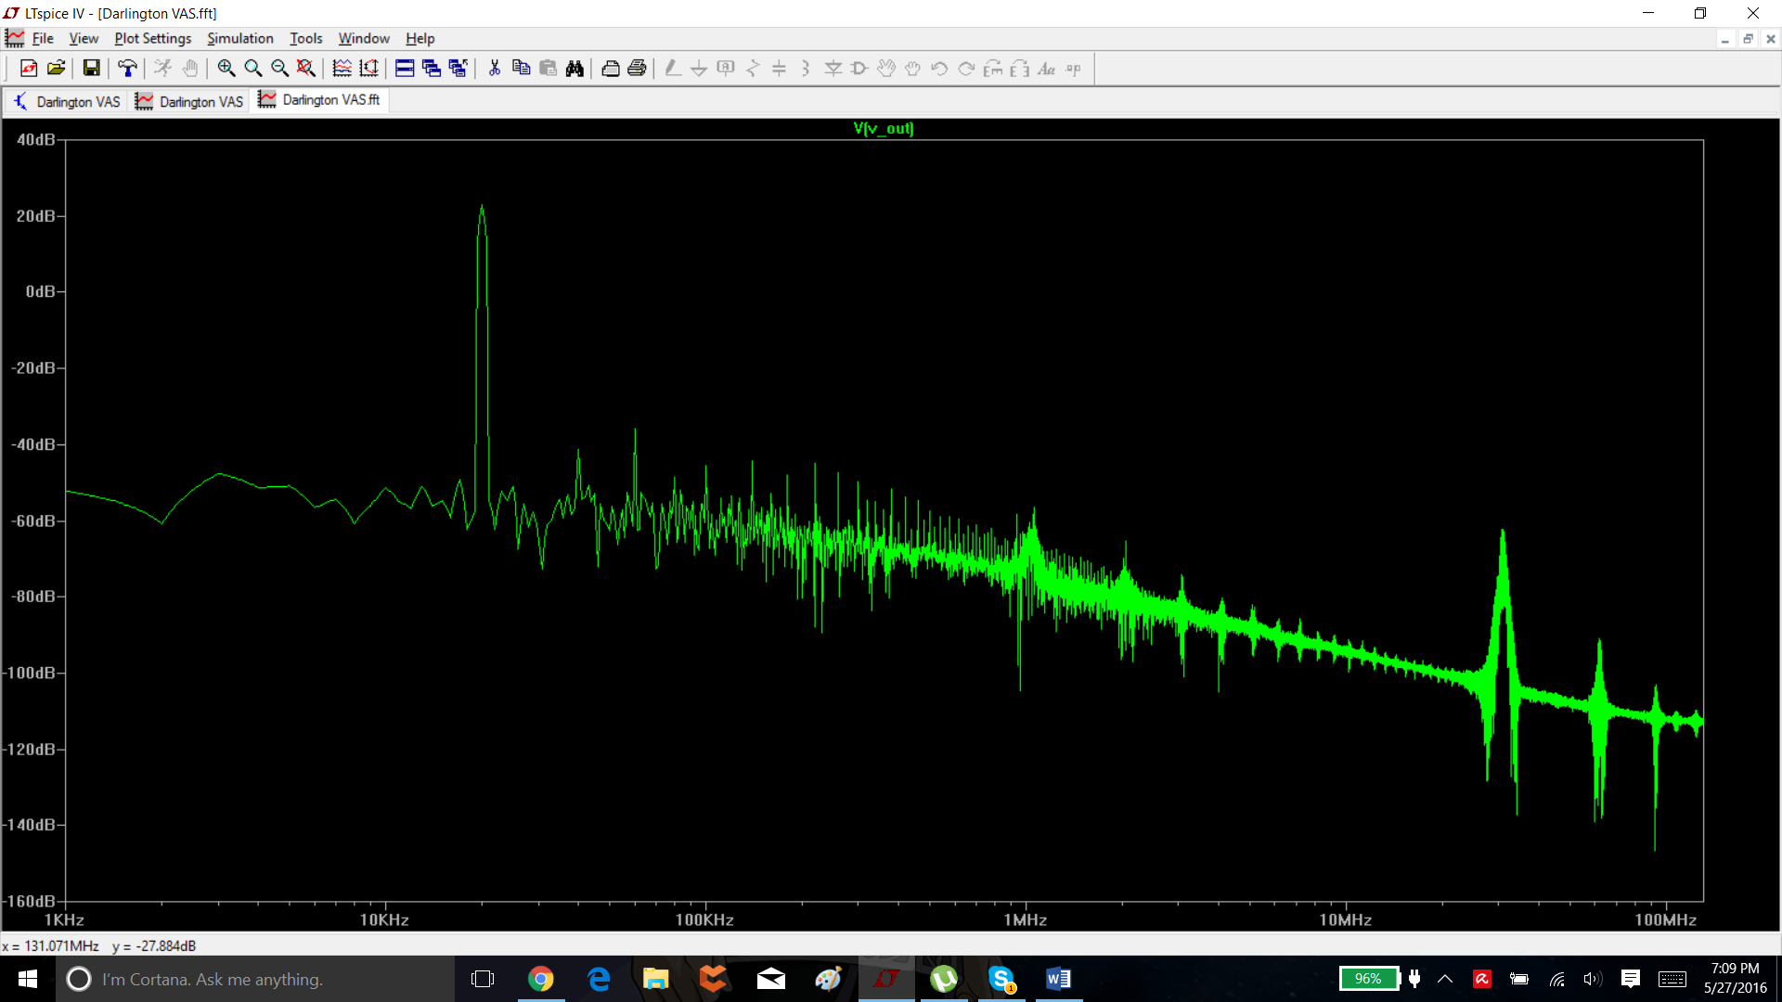

Resonances appearing in the higher frequency components.

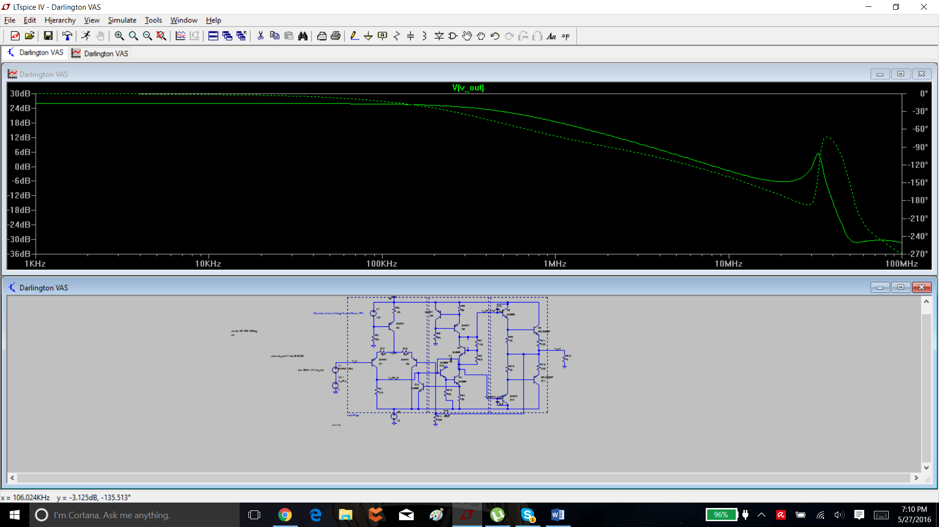

Very bad margins at higher frequencies. Transistors added a resonance.

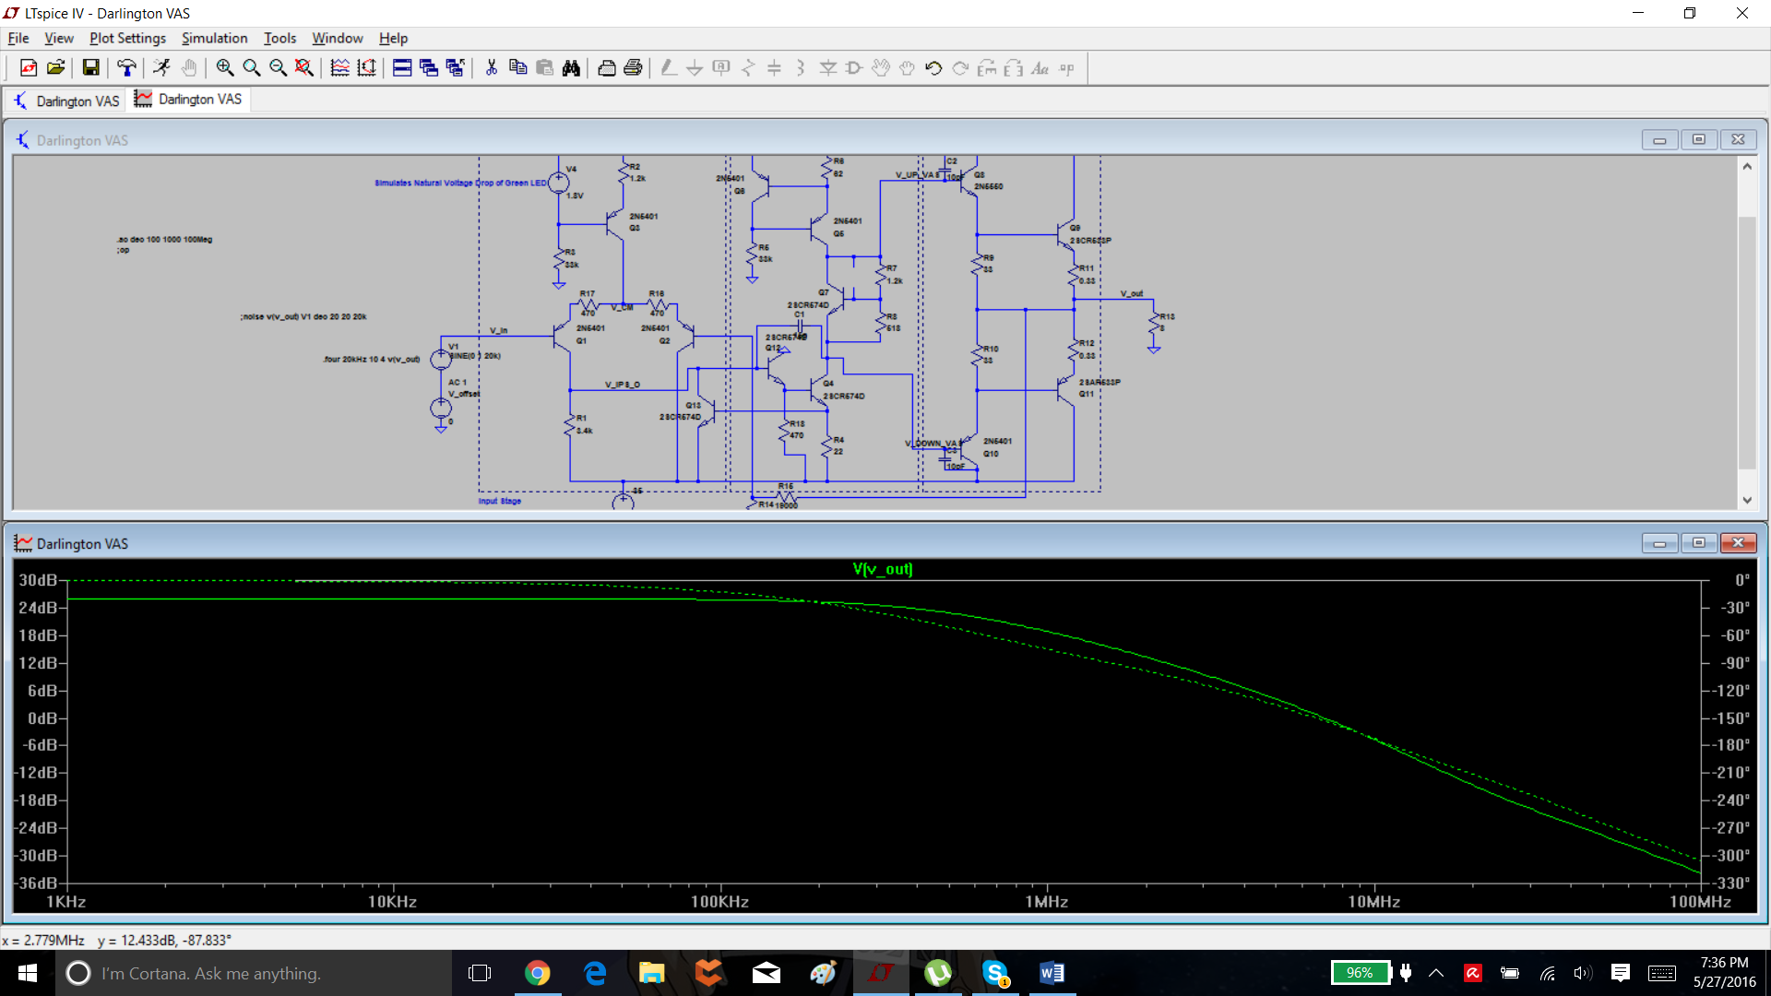

Switched around transistors. Smoothed out response.

Fourier components of V(v_out)

DC component:-1.65775

Harmonic Frequency Fourier Normalized Phase Normalized

Number [Hz] Component Component [degree] Phase [deg]

1 2.000e+04 1.977e+01 1.000e+00 -2.55° 0.00°

2 4.000e+04 2.513e-03 1.271e-04 -140.94° -138.38°

3 6.000e+04 2.018e-02 1.021e-03 -117.13° -114.57°

4 8.000e+04 7.539e-03 3.813e-04 134.83° 137.38°

5 1.000e+05 1.856e-02 9.388e-04 -118.12° -115.57°

6 1.200e+05 1.037e-02 5.246e-04 137.32° 139.88°

7 1.400e+05 1.845e-02 9.330e-04 -131.80° -129.25°

8 1.600e+05 1.263e-02 6.391e-04 131.94° 134.50°

9 1.800e+05 1.383e-02 6.994e-04 -133.28° -130.73°

10 2.000e+05 1.517e-02 7.674e-04 124.17° 126.72°

Total Harmonic Distortion: 0.217176%(0.372630%)

THD-20 got worse. :/

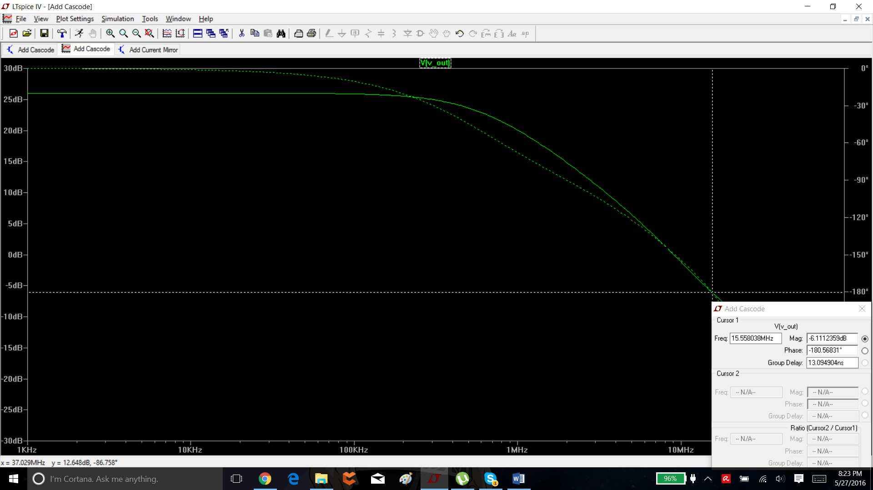

Added current mirror

Fourier components of V(v_out)

DC component:0.00228046

Harmonic Frequency Fourier Normalized Phase Normalized

Number [Hz] Component Component [degree] Phase [deg]

1 2.000e+04 1.990e+01 1.000e+00 -2.41° 0.00°

2 4.000e+04 3.997e-03 2.008e-04 -25.53° -23.12°

3 6.000e+04 2.664e-02 1.338e-03 -47.37° -44.96°

4 8.000e+04 2.989e-03 1.502e-04 -134.58° -132.17°

5 1.000e+05 1.214e-02 6.098e-04 -88.91° -86.50°

6 1.200e+05 1.615e-03 8.116e-05 60.38° 62.79°

7 1.400e+05 9.396e-03 4.721e-04 -177.29° -174.88°

8 1.600e+05 1.978e-03 9.940e-05 -17.73° -15.32°

9 1.800e+05 4.117e-03 2.069e-04 -152.40° -149.99°

10 2.000e+05 1.281e-03 6.437e-05 -159.78° -157.37°

Total Harmonic Distortion: 0.158507%(0.201402%)

Slight decrease in THD 20.

Adding Cascoded VAS doesn’t significantly improve performance. Increases THD slightly.

***LESSON LEARNED. USE FEW CYCLES FOR MORE FIDELITY SO THE THD DOESN’T GO ALL OVER THE PLACE.***

***THD 20 WITH 0.5MS FOR ALL***

***NONE***

Harmonic Frequency Fourier Normalized Phase Normalized

Number [Hz] Component Component [degree] Phase [deg]

1 2.000e+04 1.994e+01 1.000e+00 -1.50° 0.00°

2 4.000e+04 7.723e-03 3.874e-04 70.60° 72.10°

3 6.000e+04 1.400e-02 7.022e-04 -98.79° -97.29°

4 8.000e+04 9.749e-04 4.891e-05 79.69° 81.19°

5 1.000e+05 6.447e-03 3.234e-04 -105.31° -103.81°

6 1.200e+05 6.686e-04 3.354e-05 13.24° 14.74°

7 1.400e+05 5.800e-03 2.909e-04 -126.22° -124.72°

8 1.600e+05 7.194e-04 3.609e-05 49.87° 51.37°

9 1.800e+05 4.537e-03 2.276e-04 -125.15° -123.65°

10 2.000e+05 2.354e-04 1.181e-05 122.38° 123.88°

Total Harmonic Distortion: 0.094295%(0.116627%)

***Emitter Degen***

Fourier components of V(v_out)

DC component:-8.22444

Harmonic Frequency Fourier Normalized Phase Normalized

Number [Hz] Component Component [degree] Phase [deg]

1 2.000e+04 1.890e+01 1.000e+00 -15.57° 0.00°

2 4.000e+04 6.293e-02 3.330e-03 -171.53° -155.96°

3 6.000e+04 1.342e-02 7.103e-04 -121.44° -105.86°

4 8.000e+04 3.605e-02 1.908e-03 55.18° 70.76°

5 1.000e+05 1.628e-02 8.614e-04 -42.78° -27.21°

6 1.200e+05 9.052e-03 4.791e-04 33.99° 49.56°

7 1.400e+05 2.033e-02 1.076e-03 -85.75° -70.18°

8 1.600e+05 7.751e-03 4.102e-04 162.51° 178.08°

9 1.800e+05 9.151e-03 4.843e-04 -115.70° -100.13°

10 2.000e+05 1.291e-02 6.830e-04 132.94° 148.51°

Total Harmonic Distortion: 0.427008%(0.438812%)

***Darlington***

Fourier components of V(v_out)

DC component:0.490692

Harmonic Frequency Fourier Normalized Phase Normalized

Number [Hz] Component Component [degree] Phase [deg]

1 2.000e+04 1.984e+01 1.000e+00 -2.47° 0.00°

2 4.000e+04 2.408e-03 1.214e-04 -84.89° -82.41°

3 6.000e+04 7.501e-03 3.781e-04 -99.38° -96.91°

4 8.000e+04 1.103e-03 5.560e-05 -59.70° -57.22°

5 1.000e+05 8.239e-03 4.153e-04 -125.34° -122.87°

6 1.200e+05 2.038e-03 1.027e-04 -65.16° -62.69°

7 1.400e+05 7.818e-03 3.941e-04 -140.49° -138.02°

8 1.600e+05 1.328e-03 6.693e-05 -39.99° -37.51°

9 1.800e+05 6.203e-03 3.126e-04 -138.75° -136.28°

10 2.000e+05 1.671e-03 8.424e-05 -73.51° -71.04°

Total Harmonic Distortion: 0.078001%(0.107423%)

***Current Mirror***

Fourier components of V(v_out)

DC component:0.0613738

Harmonic Frequency Fourier Normalized Phase Normalized

Number [Hz] Component Component [degree] Phase [deg]

1 2.000e+04 1.996e+01 1.000e+00 -2.43° 0.00°

2 4.000e+04 2.603e-03 1.304e-04 -18.53° -16.10°

3 6.000e+04 1.051e-02 5.267e-04 -83.14° -80.71°

4 8.000e+04 1.562e-03 7.825e-05 -155.81° -153.38°

5 1.000e+05 7.048e-03 3.531e-04 -111.35° -108.92°

6 1.200e+05 9.959e-04 4.990e-05 -23.04° -20.62°

7 1.400e+05 7.266e-03 3.641e-04 -136.78° -134.36°

8 1.600e+05 9.260e-04 4.639e-05 1.43° 3.86°

9 1.800e+05 6.383e-03 3.198e-04 -134.20° -131.77°

10 2.000e+05 8.837e-04 4.427e-05 -124.73° -122.30°

Total Harmonic Distortion: 0.081649%(0.114738%)

***Cascode***

Fourier components of V(v_out)

DC component:0.0632387

Harmonic Frequency Fourier Normalized Phase Normalized

Number [Hz] Component Component [degree] Phase [deg]

1 2.000e+04 1.996e+01 1.000e+00 -2.43° 0.00°

2 4.000e+04 1.139e-03 5.709e-05 19.93° 22.36°

3 6.000e+04 9.626e-03 4.823e-04 -80.48° -78.06°

4 8.000e+04 5.346e-05 2.678e-06 -66.21° -63.78°

5 1.000e+05 8.452e-03 4.235e-04 -105.18° -102.76°

6 1.200e+05 1.395e-03 6.990e-05 -61.71° -59.29°

7 1.400e+05 7.851e-03 3.933e-04 -139.17° -136.74°

8 1.600e+05 3.559e-04 1.783e-05 9.22° 11.65°

9 1.800e+05 5.942e-03 2.977e-04 -136.83° -134.41°

10 2.000e+05 5.739e-04 2.875e-05 -158.19° -155.76°

Total Harmonic Distortion: 0.081518%(0.110285%)

Fourier components of V(v_out)

DC component:0.0626517

***Final***

Harmonic Frequency Fourier Normalized Phase Normalized

Number [Hz] Component Component [degree] Phase [deg]

1 2.000e+04 1.997e+01 1.000e+00 -1.21° 0.00°

2 4.000e+04 1.569e-03 7.859e-05 66.91° 68.12°

3 6.000e+04 6.459e-03 3.234e-04 -78.93° -77.72°

4 8.000e+04 1.076e-03 5.388e-05 74.86° 76.07°

5 1.000e+05 7.073e-03 3.542e-04 -70.32° -69.11°

6 1.200e+05 2.646e-03 1.325e-04 -81.15° -79.94°

7 1.400e+05 6.909e-03 3.460e-04 -113.82° -112.61°

8 1.600e+05 2.469e-04 1.236e-05 45.36° 46.58°

9 1.800e+05 5.716e-03 2.863e-04 -117.75° -116.53°

10 2.000e+05 5.262e-04 2.635e-05 59.05° 60.27°

Total Harmonic Distortion: 0.067765%(0.118362%)